Jira Lab Setup and Learning
Learning:
https://youtu.be/NDVSMlVYxm8?si=0VCQasAplEIquO0_
https://www.atlassian.com/agile

Link:
https://www.atlassian.com/software/jira?campaign=18442427757&adgroup=143485223644&targetid=kwd-855725830&matchtype=e&network=g&device=c&device_model=&creative=656562805594&key word=jira&placement=&target=&ds_eid=700000001558501&ds_e1=GOOGLE&gad_source=1&gad_campaignid=18442427757
Step 1: Copy-paste the above link in your browser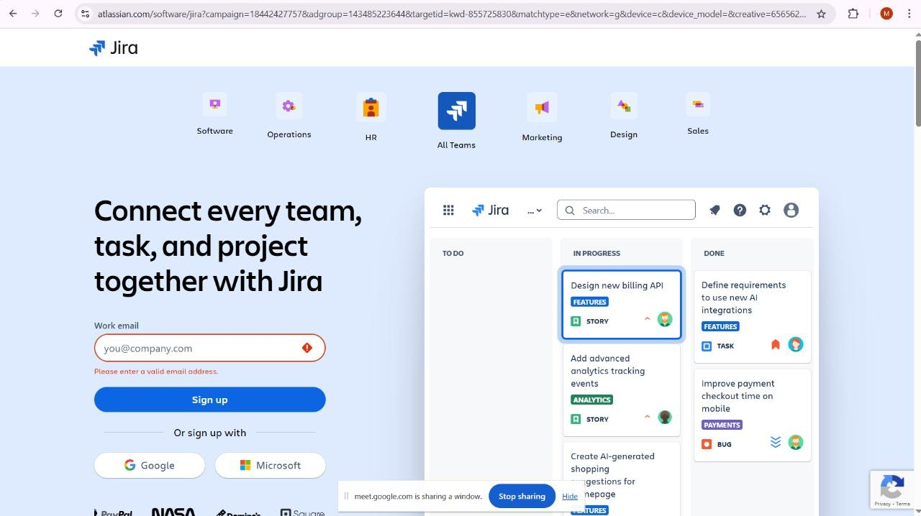
Step 2: Sign Up with you Google account for your Free Jira Account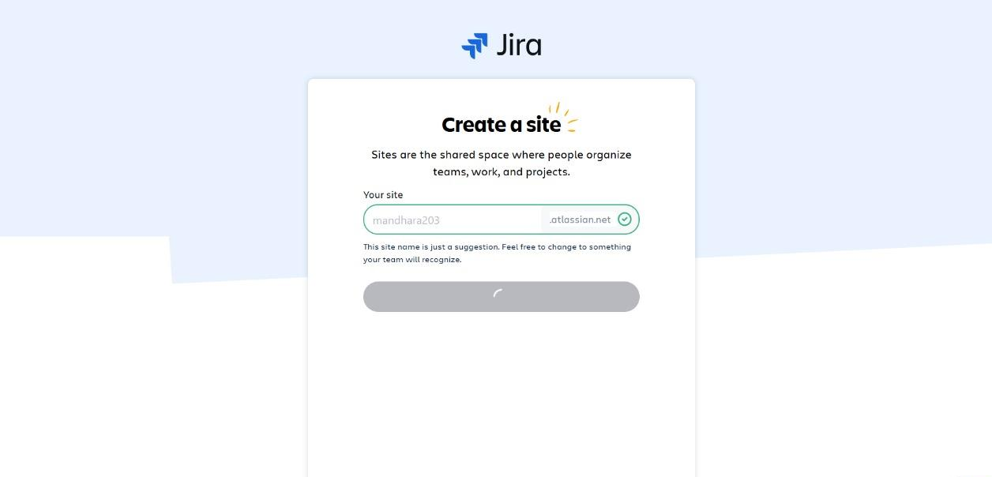Step 3: Choice an appropriate username and continue with the creation of the username subdomain.
username.atlassian.net is a subdomain used by Atlassian, specifically for accessing Atlassian cloud products. It represents a unique site within the Atlassian ecosystem, often associated with a specific organization or team using Atlassian products like Jira, Confluence, or Bitbucket. The "username" part of the URL is a placeholder and would be replaced by the actual username or site identifier associated with an Atlassian account.
Step 4: Click on Software Development and continue
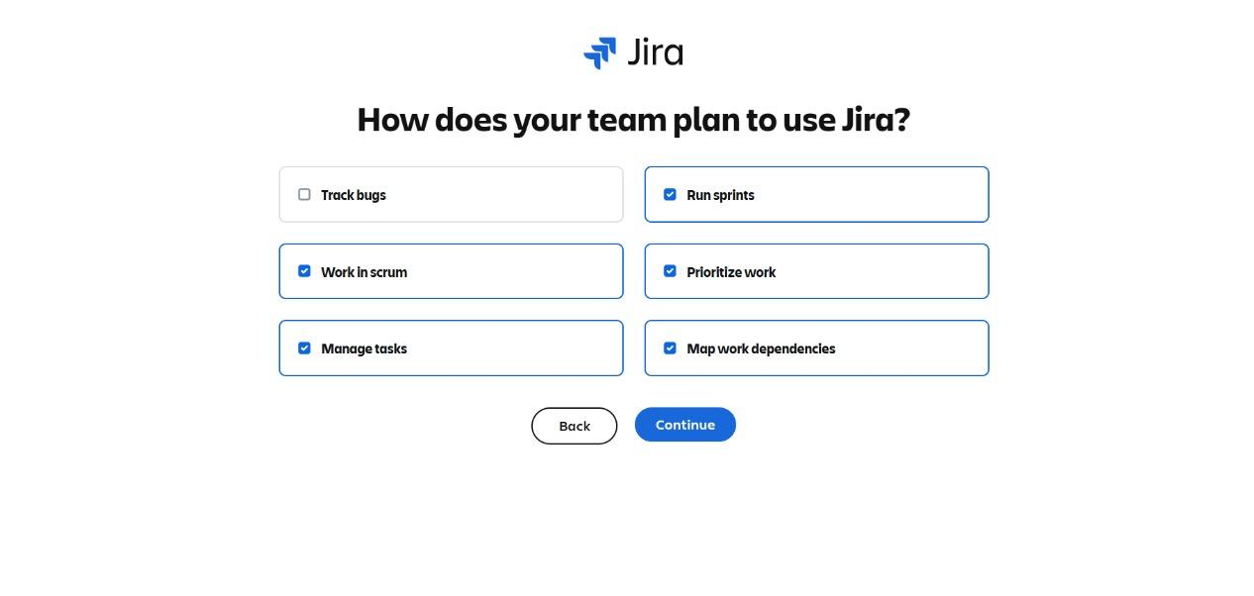Choose the above mentioned, you may feel free to choose them all as well. And click continue.
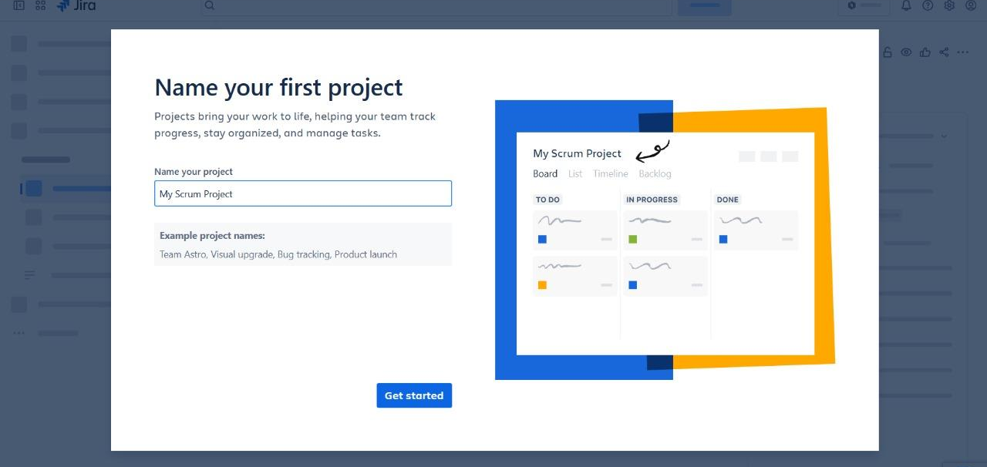
Now this is where you create your SCRUM and KANBAN boards for your respective Projects.
Step 5: Name you Project same as the Lab 1 component, (e.g.: - Coffee Kiosk) and click get started.
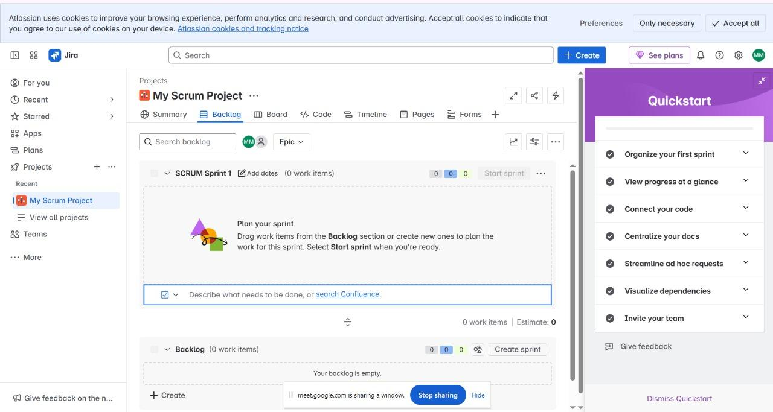
This is your SCRUM board for your lab today. Feel free to go through the QuickStart to explore the different aspects of what Jira has to offer.

This marks the end of Account SETUP for Lab 2: Jira.

